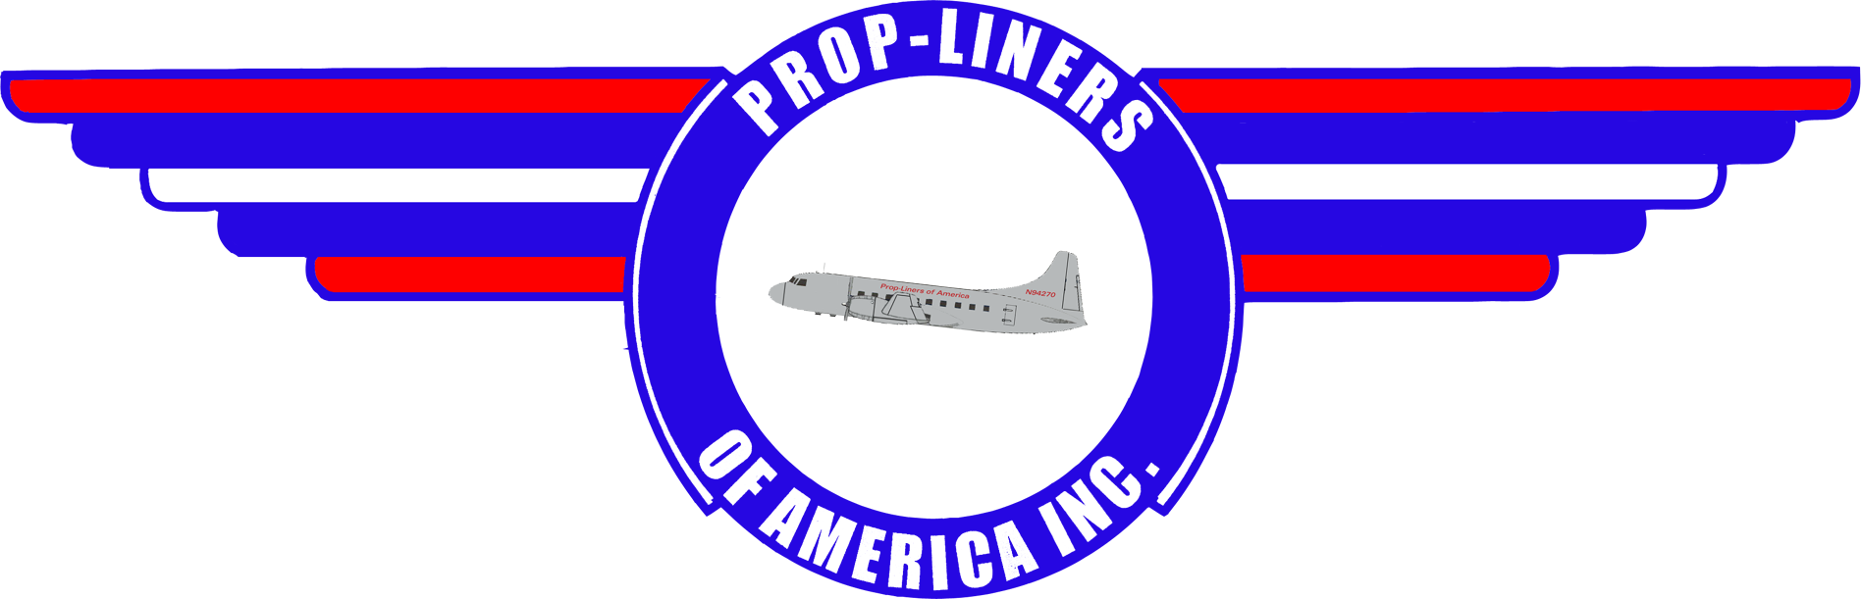

58 Lindbergh Dr.
Brainard Airport
Hartford, CT 06114 www.prop-liners.com
1st Qtr 2002 Prop-Liners of America, INC. Volume 7
Our Work Continues in 2002  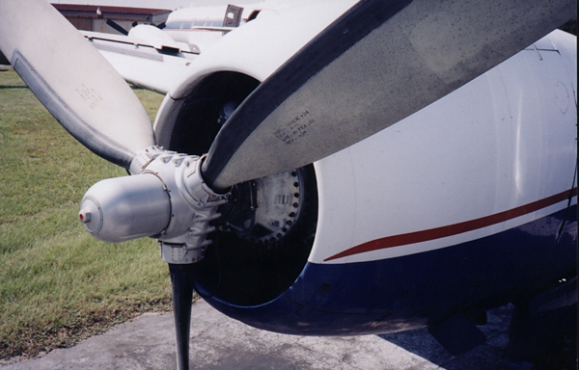  Previously we reported that the FAA had granted a waiver on the prop overhaul by performing the ADs. This waiver has been pulled which means the prop overhaul is once again scheduled at a cost of $11,000. This means that initial engine startup won’t occur until the overhaul has been completed.  Power was applied to the aircraft recently. We operated the flaps and cowl flaps observing no circuit breaker trips! Additionally, avionics work continues. The existing avionics still uses vacuum tubes, the availability of which is often times inconsistent, therefore this work will be difficult and probably slow unless we can find an avionics sponsor for this effort.  From a budgetary perspective, Kenya Lewitt, our Portable Writer, is arranging for private foundation grants to finance the aircraft. Bill Bradshaw, president of Prop-liners of America (POA), has decided to take a wait and see approach before seeking loans. It’s hoped that grants and sponsors will allow us to maintain and operate the 240 and a loan won’t be necessary. Our hope is to find operating capitol without an associated monthly payment!  This quarter has seen a great many donations come to POA. Paul Herrbold of Colleyville, TX donated an excellent Historical Video on the Convair 240 in Jan 2002. Paul flies an MD-80 for American Airlines and is a member of the Gray Eagles, an American Airlines group of pilots over age 50.  In January, Ken Goldblatt of Brockton, MA donated a set of post lights from a Convair that was used to light the Instrument Panel. Last year Ken also donated a Canteen that was used for coffee, this appeared to be  Continued on Page 2 | Image Corner  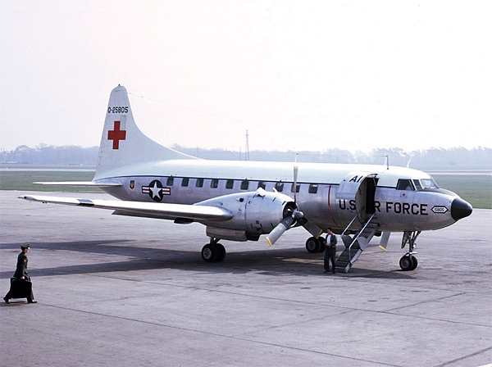  This quarter we picture a military version of the Convair prop-liner. In this case, MC-131A pictured on the ground in 1969 in Liverpool, Great Britain. Steve Williams, the photographer, has given us his permission to use this wonderful picture. You may find more of his skillful photography at WWW.AIRLINERS.NET.  A modified Convair 240, the MC-131A Samaritan was used as a medical evacuation aircraft. It had large loading doors for stretchers or cargo and was equipped to accommodate 27 stretchers or 37 sitting casualties. First delivered in 1954 the type went on to serve the active Air Force into the late 70’s though a few served National Guard units through the mid-80’s. One little known fact about the C-131 is its part in developing the side-firing gunships such as the AC-47, AC-119, and AC-130. Known as Project Tailchaser, a C-131B (AF Ser. 52-7820) was used during the period mid-1963 to mid-1964 using a General Electric SUU-11A/A 7.62mm Gatling Minigun. The results exceeded all expectations, causing the Air Force to fund further investigation of the concept. By late 1964 the program focused on a different aircraft, a Douglas C-47D, which was the direct precursor of the famous gunship known as Puff The Magic Dragon which served with distinction in Vietnam.  New & Renewed Members
  Bette DuFraine – Captains Club | Jim Michaud – Captains Club
  Lauren Hoffman – Skyrider | Leo Rochetti – Presidents Club
  Shirley Eldridge – Skyrider | Michael Rochetti – Presidents Club
  Paul Magnon – Captains Club | Roberta Rochetti – Presidents Club
Prop-Liners of America, INC. Page 2
About This Issue  Prop-Liners of America Newsletter is the official news source for our non-profit organization complementing the website at  www.prop-liners.com.  All content is the property of Prop-Liners of America, INC and may be reproduced without permission.  If you have a Prop-Liner story and would like to submit it for publication. please send it to the editor.  Editor: Del Laughery dlaughery@snet.net  Contributing Writers: Bill Bradshaw & Del Laughery  Contact Information  Address:  Prop-Liners of America, INC  P.O. Box 198  Stafford Springs, CT 06076-0198  Airport Address:  Prop-Liners of America, INC  58 Lindbergh Drive  Brainard Airport  Hartford, CT 06114-2123  Web Site:  www.prop-liners.com  email:  wbradshaw@snet.net or  wbradshaw@prop-liners.com  phone: 860 684-4988  -------------------------------------------------------------------------  Quick Fact  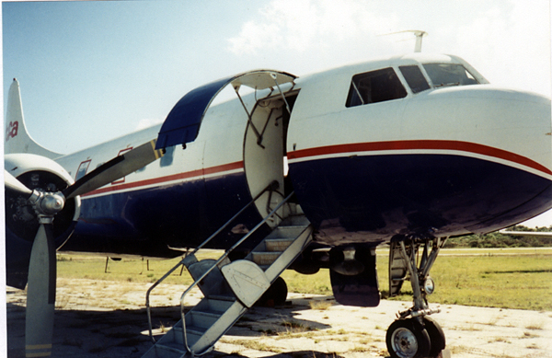  A characteristic peculiar to the 240 was the right side entry door. | Our Work (from Page 1)  from possibly a Boeing 377 or a Connie.  Dick Whiting continues to donate to us from his vast collection of many photos & memorabilia. Dick also serves on our Board of Directors as the Director of Fund Raising & Director of East Coast Recruitment, Dick is a busy guy. Also Dick's father used to fly  for Eastern Airlines, Lockheed Connies & DC-'s!! Keep up the great work Dick!!  Gary & Alicia Plomp from Daly City, CA have made a number of cash donations in the past few years as well as photos & memorabilia. Gary is also on our Board of Directors as the Director of West Coast Recruitment. Gary has been responsible for getting out the word on the West Coast and is doing a great job!! Many thanks Gary!  Gerard J. Rock Jr. of Rockville, CT made a cash donation at the end of 2001. Thanks very much Gerry, we need more good folks like you.  Connel Internet Marketing, they are the folks that host our Web Site and keep us in the loop with the search engines and make it possible to get the word out through the internet. These fine people have donated 50 megs of Web Site Space for POA, Thank You Connel, Roberta, Michael & Leo  Rocchetti.  Exxel Avionics @ HFD Brainard Airport in Hartford, CT has donated three lighted display cases for the POA Educational Research Center Museum. Exxel is located at the North end of the field, many thanks to Steve Christino for this fine donation.  Additional space has been acquired for the planned POA museum where prop-liner memorabilia will be displayed. Painting and preparation has just begun at Millionaire (soon to be known as Atlantic Air) at Brainard Airport. The opening date is still TBD, but we’ll let you know as soon as we do!  Lastly, mark your calendars for June 1 & 2. POA will have a tent set up at the Hanscomb Field Airshow. Come by and introduce yourself as a member. We’re always happy to see our members.
Prop-Liners of America, INC. Page 3

Promotional Items Order Form

Item Price Size Quantity Total

Navy Blue Adjustable Baseball Hat with Prop-Liners logo $6.00
Gray T-shirt w/ Prop-Liner logo over left breast $8.00 L XL
Navy blue T-shirt w/Prop-Liners logo on back $8.00 L XL
License Plate w/Prop-Liners logo $4.00
License Plate Frame w/Prop-Liners logo $3.00
Convair 240 Vinyl Decal $2.00
Convair 240 8X10 Color Photo $2.00
Shipping $3.95

Total

Membership Information and Application
See our website at www.prop-liners.com to view details of each membership type.

Membership Types (circle your choice of membership):
Flagship Club: $5000 for lifetime membership
Presidents Club: $1000 for lifetime membership
Captains Club: $500/year
Skyrider: $250/year
Ground Crew: $100/year
Observer: $40/year
Name:
Street:
City: State: Zip Code:
Phone (including area code): ( ) email Address:

If your membership level entitles you to a T-Shirt, please circle the size desired: L XL

Make all promotional material and membership checks payable to Prop-Liners of America, INC.
and send it along with this form to:
Prop-Liners of America, INC.
PO Box 198
Stafford Springs, CT 06076-0198

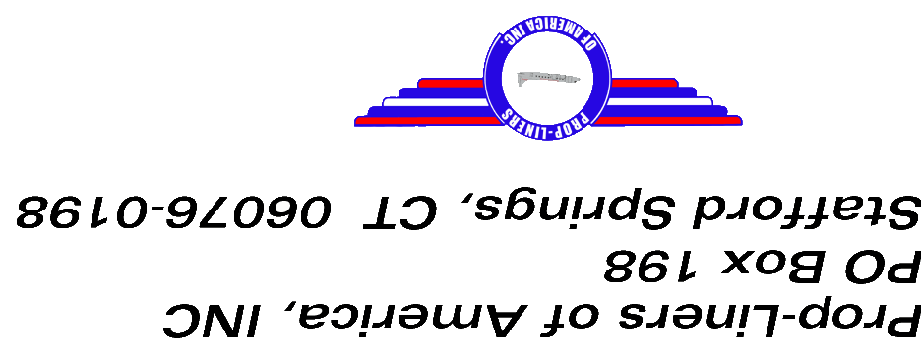
Photographs of our Convair 240

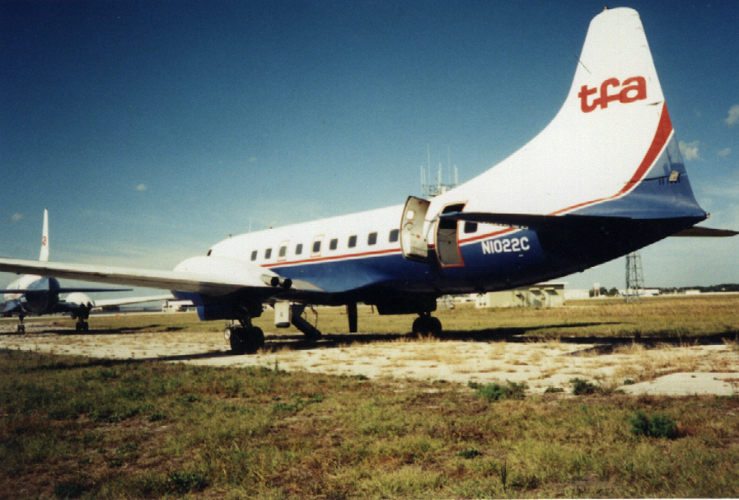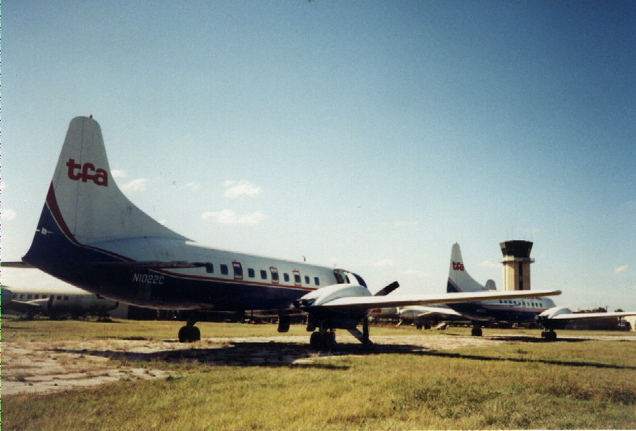

Sponsors  Please support our very important sponsors!               |     

