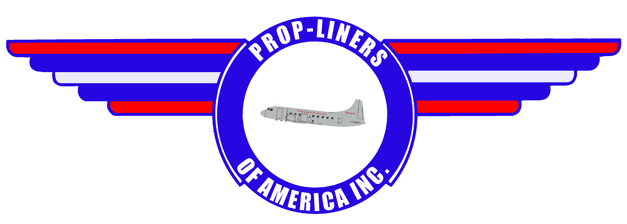

Volume 13 58 Lindbergh Dr Brainaird Airport Hartford, CT 06114 2nd Quarter 2006

  The big news around Prop-Liners is the arrival of a donated Convair 440, N323CF, from Four Star Aviation in Puerto Rico. The aircraft is currently undergoing  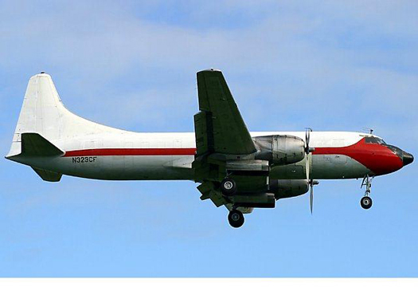  a thorough inspection by our friends at TransFlorida Airlines in Daytona, FL, as are the associated logs that came with it. The addition of this donated aircraft to Prop-Liners gives us the ability to sell it or trade it, or even fly it, to benefit the organization. Ultimately, we  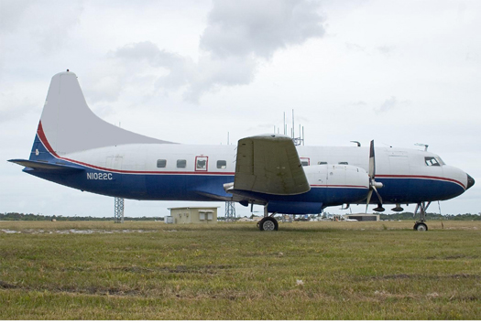  (Continued on Pg. 2) | Image Corner  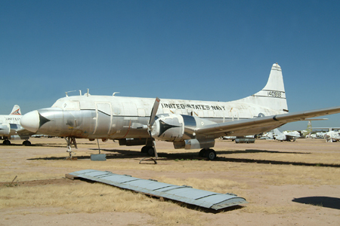  Navy Convair R4Y-1 Samaritan (Convair model 340), BuNo. 140998, arrived at AMARC in April 1981. This aircraft was to be sold to a civilian operator as N5249W, but the sale fell through and here this old transport remains.  The T-29/C-131 series of aircraft was one of the military's many cost saving examples for its utility and transport needs. The first T-29 military Convair 240 Convair-Liner was accepted March 8, 1950, and the first C-131 was delivered in 1954. Military production eventually eclipsed civil production with the last Convair-Liner being a military Canadair CL-66B. A total of 472 military Convair-Liners were built. Today the Convair-Liner continues to fly on both civilian and military rosters, attesting to its reliability throughout the years. Some were used as navigation trainers, others as transports.  The T-29 "Flying Classroom" aircraft was used by the Air Force for navigator training, having individual stations and instruments for each of the 10 students who would take turns navigating the aircraft. The Navy used the T-29 “Seastars” [the C-131F variant initially designated R4Y-1] to train student aviators in basic instrument flying. The current T-43 replaced the T-29 for training navigators.

Prop-Liners of America, INC Page 2
want our 240, N1022C to fly, and this 440 may be just the ticket to getting the money – always a problematic issue – to complete its restoration to flying status. Stay tuned! As a reminder, our 240 flew with Mohawk airlines for a time and still retains the original Mohawk interior.  Last Fall, a hardy group of Prop-Liners members congregated at our Brainard Airport location to paint our airline stairs. As you can see, the ex-TWA stairs turned out quite nicely.  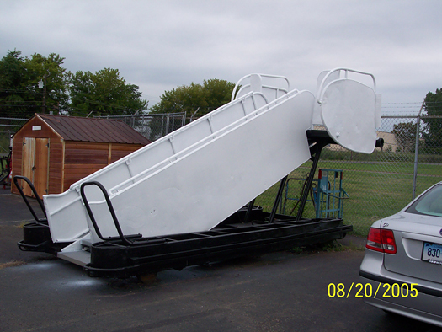  We have planned a POA Glalactic Bowling Party fundraiser at the Vernon Lanes Bowling Center, Vernon, CT. Tickets are $15 which includes unlimited bowling, shoe rental, and two slices of pizza and soda. The proceeds benefit POA. For more information, call Bill Bradshaw at 860 684-4988.  We have many people to thank for their selfless acts of kindness toward POA. Jon Ramer donated an original Lockheed L-1049 manual. We would like to thank the following individuals & companies for their continuing support to POA: Bill & Kathy Bradshaw, Williams Enterprises, Instructional Dynamics, Four Star Aviation, Del & Kelly Laughery, Al Mitchel, Al & Audrey Schmid, John & Marion Masterson, Alan Booth, Charles Cary, Edward Price, Ann Genewicz, H.S. (Buddy) Johnston, Paul & Debra Jameson, Gary & Alicia Plomp, Phil Bellingham, Bob Thompson, Bill Lambert, Gene Soja, Jon Ramer.  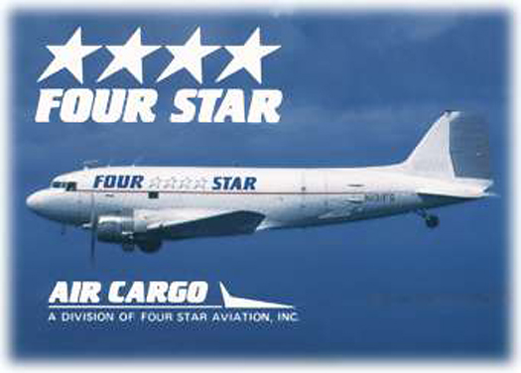 | Join Team POA  For as little as $5.00 per year you can become a member of Prop-Liners of America. You will receive an official membership card, a Convair 240 decal and the quarterly newsletter. It’s a great way to support Prop-Liners and it’s tax deductible!  Military Veterans Receive Discounted Memberships  A new membership level has been created for military veterans. They pay only half price for any Prop-Liners membership and receive full benefits as well as a 25% discount on gift shop items.  Charter Sponsor Program  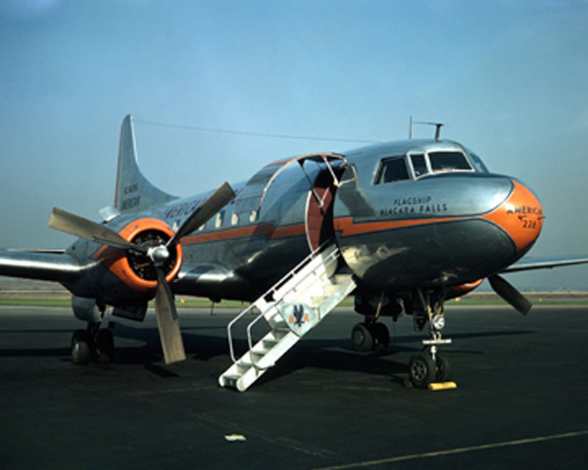  Are you looking for a way to support Prop-Liners without becoming an actual member? Charter Sponsorship allows you to assist us restore and exhibit propeller-driven airliners and military classics to honor the memory of all who served in them. Charter Sponsors receive a certificate suitable for framing, photographs of our aircraft, and their name listed on the Prop-Liners Honor Roll to be kept on permanent display at the museum at Brainard Airport.  Is It Time…  … to renew your membership with Prop-Liners? Please remember, your membership dues allow us to continue operating our museum and gift store, publish the newsletter, and continue restoration efforts on the Convair. Plus, each and every dollar you donate or spend with us is completely tax deductible.  New and Renewed Memberships  Ann & John Genewicz, H.S. (Buddy) Johnston, Mark Kendall, Phil Bellingham, Terry Clark, Robert Kramer, Francis Adams, and Bob Cranmer.

Prop-Liners of America, INC Page 3
POA Cross Word Puzzle  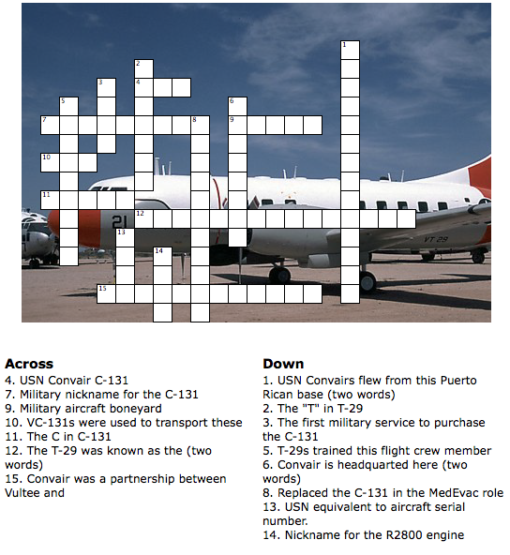  Contact Information  Web Site: www.prop-liners.com  Phone: 860 684-4988  email: Bill Bradshaw - wbradshaw@prop-liners.com  Del Laughery – cavu_only@sbcglobal.net  About This Issue  Prop-Liners of America Newsletter is the official news source for our non-profit organization, and complements the website at www.prop-liners.com. All content is the property of Prop-Liners of America, INC and may be reproduced without permission.  If you have a Prop-Liner story or picture and would like to submit it for publication, please send it to the editor.  Editor: Del Laughery - cavu_only@sbcglobal.net | Sponsors  Please support our very important sponsors!          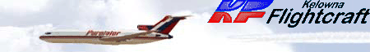          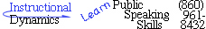  Next Meeting  The next Prop-Liners of America meeting will occur on June 3, 2006 at 2:00PM at our Brainard Airport location. Please consider attending!  Next Issue  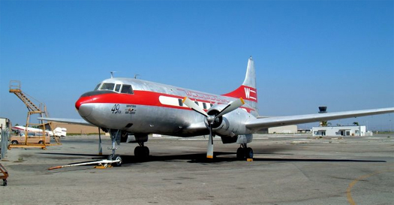Propliners in museums.  Please visit our friends at these fine museums  
  Mailing Address:  Prop-Liners of America, INC  P.O. Box 198  Stafford Springs, CT 06076-0198 | Museum Address:  Prop-Liners of America, INC  58 Lindbergh Drive  Brainard Airport  Hartford, CT 06114-2123

Prop-Liners of America, INC Page 4
Other Prop-  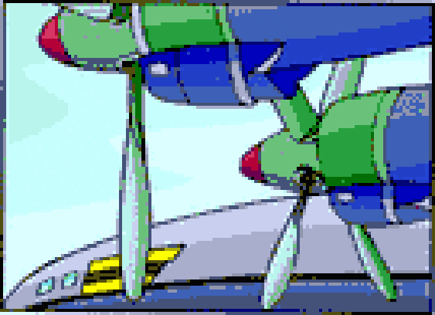  Liners  Douglas DC-3 Goony Bird, N143D, now 70 years old, is operating from Griffin, GA. Originally built for Swiss Air in 1937, it was assigned registration HB-IRO starting its service with Swiss in November 1938. It flew in that capacity until it’s retirement in 1955.  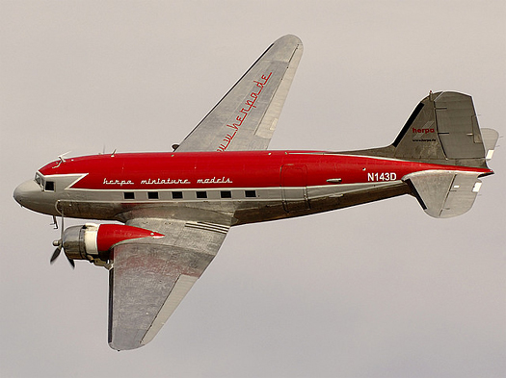  Since its retirement this aircraft has served in many roles, mostly cargo, but now it is used as a pilot training platform. The owner uses it to train PICs to fly the type. He even offers orientation flights to pilots who just want some left seat time in an old propliner. "Photos courtesy of Gus Anaya."  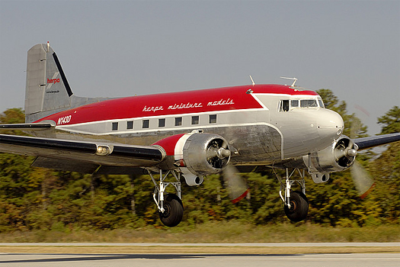 | Book Store  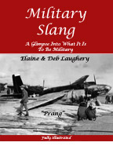  Military Slang – A humorous look at the terminology used in the US military services. Over 300 photographs. Many never before seen. Available for download, on CD, or hardcopy at www.teachu2teach.com    "The World's Premier Airline Collectible Event!"  Airliners International is the annual convention of the World Airline Historical Society where enthusiasts from around the world gather to buy, sell and trade their airline memorabilia. We also feature side trips to local aviation sites of interest.  This is the world's largest gathering of people interested in airline collectibles. Over 1,000 people attended the 2001 show in Miami, Florida. If you're interested in photos, postcards, slides, timetables, models, playing cards, stickers, and more, this event is for you!  WORLD AIRLINE HISTORICAL SOCIETY, INC.  P.O. Box 660583  Miami Springs, FL 33266 USA  http://www.WAHOSOnline.com  Information@WAHSOnline.com

Promotional Items Order Form

Item Color Price Size Quantity Total

Adjustable Baseball Hat with Prop-Liners logo * ______* $8.00
Gray T-shirt w/ Prop-Liner logo over left breast $8.00 L XL
T-shirt w/Prop-Liners logo on back ** ______** $8.00 L XL
License Plate w/Prop-Liners logo $4.00
License Plate Frame w/Prop-Liners logo $3.00
Convair 240 Vinyl Decal $2.00
Convair 240 8X10 Color Photo $2.00
Shipping*** $5.95 or $1.95
* Available in Navy, Royal, Black, Lt. Green, Dark Green, & Burgundy
** Available in Navy, Royal, Black, Green, & Purple Grand Total
***All items are shipped Priority Mail within the U.S. Please add $5.95 for
shipping and handling. Pictures & decals, if ordered separately, will be shipped
parcel post. Please add only $1.95 for shipping and handling.

Membership Information and Application
See our website at www.prop-liners.com to view details of each membership type.

Membership Types (circle your choice of membership):
Presidents Club: $1000 for lifetime membership
Captains Club: $500 for the first year, $400 for the second year, which elevates you to a lifetime membership.
Skyrider: $250/year
Ground Crew: $100/year
Observer: $40/year
Family $75/year
Name:

Street:
City: State: Zip Code:
Phone (including area code): ( ) email Address:

If your membership level entitles you to a T-Shirt, please circle the size desired: L XL

Make all promotional material and membership checks payable to Prop-Liners of America, INC.
and send it along with this form to:
Prop-Liners of America, INC.
PO Box 198
Stafford Springs, CT 06076-0198
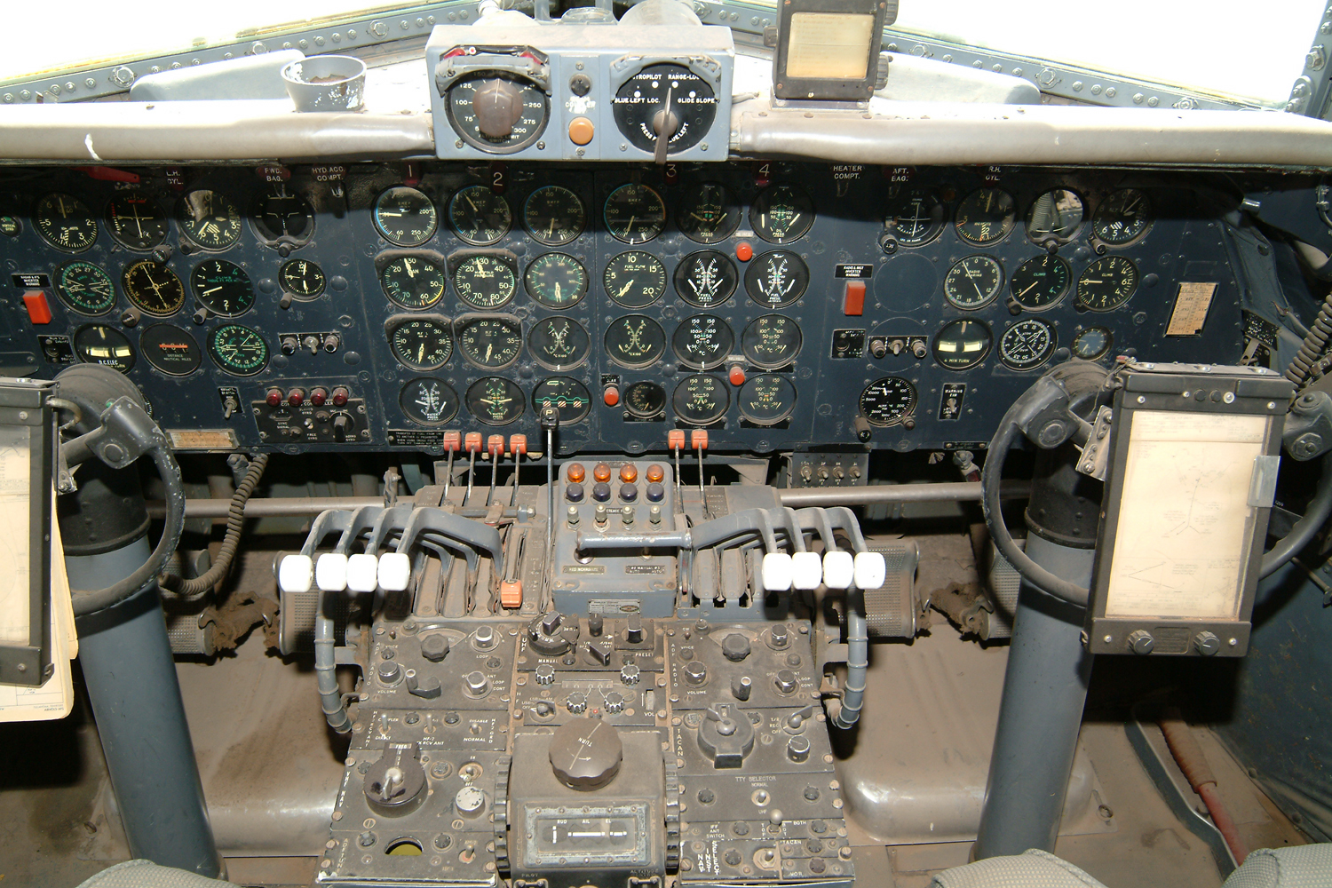
VC-118 Cockpit
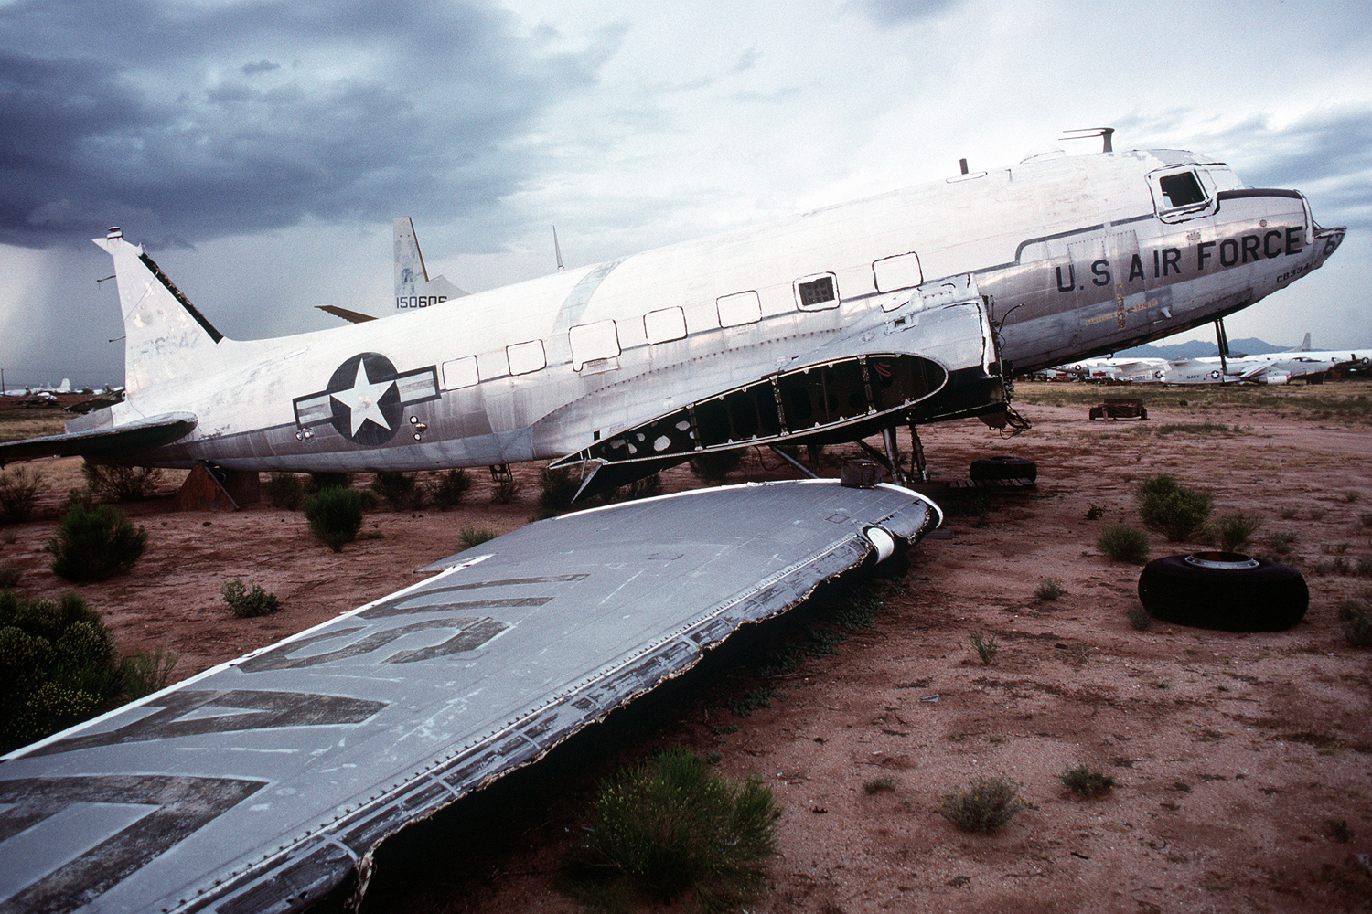
C-47, AF serial 44-76643, in storage at AMARC

