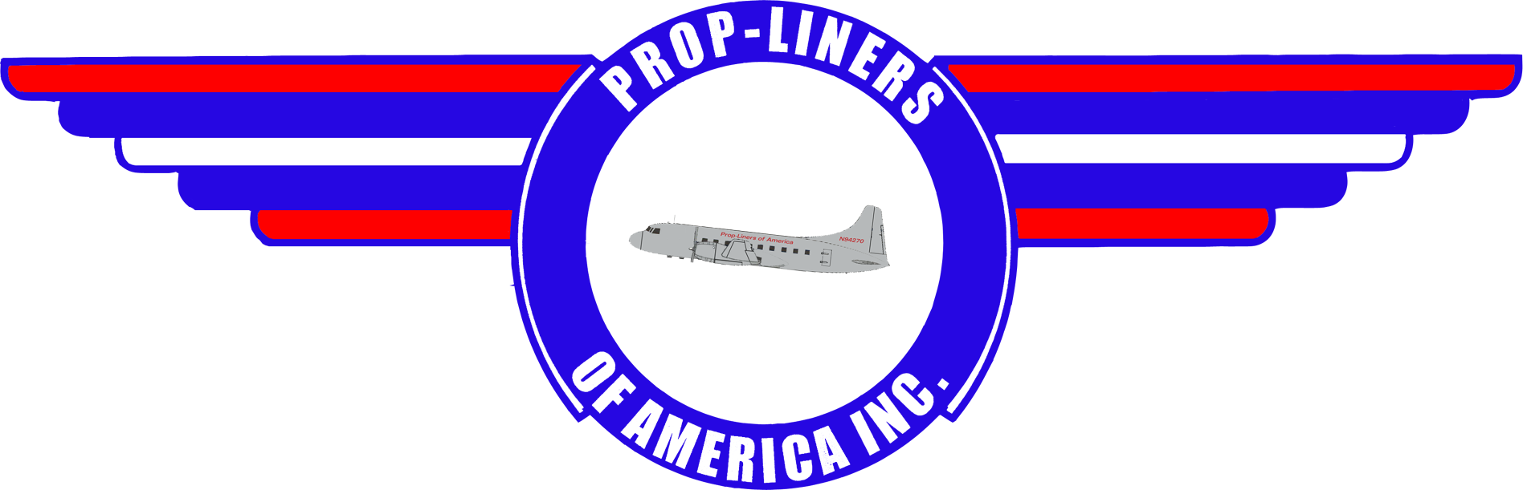

58 Lindbergh Dr.
Brainard Airport
Hartford, CT 06114 www.prop-liners.com
4th Qtr 2001 Prop-Liners of America, INC. Volume 6
The Year That Was  As the 4th quarter of 2001 comes to a close, Prop-Liners finds itself positioned to look forward to the 2002 air show schedule. Even though we've not made any specific commitments, the aircraft will soon change homes from its current location in Florida (still undergoing maintenance) to Brainard Field in downtown Hartford. Let's review the current condition of the aircraft.  Trans-Florida Airlines, one of our valued sponsors, is currently performing preventive maintenance on the 240's avionics and electrical systems. This is the last major milestone before she's ready to fly again. As indicated in our last newsletter, we've already got the engines and prop assemblies back on the aircraft, but what we couldn't report then and can now, is that we've received a waiver from the FAA on the prop overhaul by performing the ADs. This means that the 240 will soon be the queen of Brainard Field, and shortly thereafter start appearing on the air show circuit.  Also mentioned in the last newsletter was the news of a wonderful donation from Norman & Eric Flitcroft in the form of a set of TWA boarding stairs (pictured).  Though not much to look at now, we'll soon have the old paint removed, then primered & painted. Finally we'll add the Prop-Liners logo to the side.  These boarding stairs were last used at Dulles Airport in 1980 as indicated by the expiration sticker (inset) found on the left side of the base of the stairs (arrow). We'll keep you updated as the stairs undergo restoration.  Lastly, don't forget to visit the website for the most up to date information concerning our beautiful bird at www.prop-liners.com. | 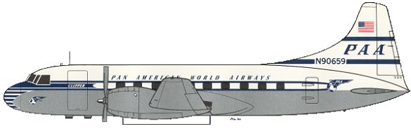  Image Corner  This quarter's image depicts Convair 240-2 in Pan American Airways colors. This aircraft was #34 off the  Convair assembly line, eventually flying for Northeast Airlines and Varig Airlines when her PAA days were  finished (4/48 - 3/54).  The fate of this aircraft is unknown.  Sponsors  Please support our very important sponsors!            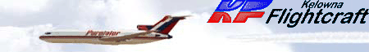        New & Renewed Members
  Del Laughery – Presidents Club | John Mountain – Captains Club
  John Killoran – Captains Club | Michael Waters – Skyrider
  Gregory Chafee – Skyrider | Sally Night – Ground Crew
  Roger Brower – Ground Crew | Stan Solomon – Ground Crew
  Paul Jameson – Ground Crew | Deb Jameson – Ground Crew
  H. S. Johnston – Observer | Walter F. Rittman - Observer
Prop-Liners of America, INC. Page 2
Charter Membership Extension!  Bill Bradshaw, President of Prop-Liners recently announced he would extend the date for charter memberships from 12/31/01 to 12/31/02, affording those who have been considering joining us to do so under this class of membership.  About This Issue  Prop-Liners of America Newsletter is the official news source for our non-profit organization complementing the website at  www.prop-liners.com.  All content is the property of Prop-Liners of America, INC and may be reproduced without permission.  If you have a Prop-Liner story and would like to submit it for publication. please send it to the editor.  Editor: Del Laughery dlaughery@snet.net  Contributing Writers: Bill Bradshaw & Del Laughery  Contact Information  Address:  Prop-Liners of America, INC  P.O. Box 198  Stafford Springs, CT 06076-0198  Airport Address:  Prop-Liners of America, INC  58 Lindbergh Drive  Brainard Airport  Hartford, CT 06114-2123  Web Site:  www.prop-liners.com  email:  wbradshaw@snet.net or  wbradshaw@prop-liners.com  phone: 860 684-4988 | The Convair 240  Searching for a replacement for the venerable Douglas DC-3 in 1945, American Airlines initiated a design requirement for a modern, pressurized, twin-engined, 40-seat airliner for use in local service. The product was the Convair 240 (with "2" engines and "40" passengers - hence the name). As launch customer, American placed an initial order for 100 of the new CV-240s (later reduced to 75). Fifty more were ordered by Western Airlines, Continental Airlines, Pan American Airways, KLM, and Trans-Australia Airlines. The CV-240 first flew on March 16, 1947 with the first delivery to American on February 28, 1948. It was the first pressurized twin-engined airliner to enter service.  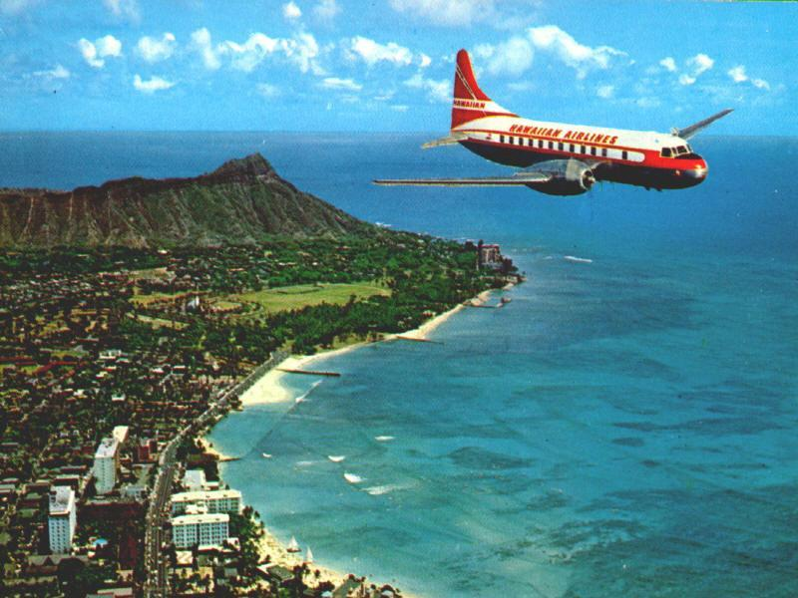  The Convair 240 is an all metal, low-wing multi-spar monoplane with hydraulically-powered Fowler flaps and was fitted with a retractable tricycle landing gear. The rudder and trailing edges of the elevator were made of fiberglass. Power was provided by two Pratt & Whitney Double Wasp R-2800-CA3 eighteen cylinder air-cooled engines, each producing 2,400 horsepower. Some additional thrust was provided by an exhaust-augmented cooling system. The engines were housed in a clever four-panel clamshell cowling which permitted virtually unrestricted access for maintenance. The pressurized fuselage was circular in cross-section and sat 40 passengers four abreast in ten rows. The cockpit was designed for two-pilot operation.  The Convair 240 has a span of 91 feet, 9 inches, a length of 74 feet 8 inches, a height of 26 feet 11 inches, and a wing area of 817 square feet. Empty weight of the original design was 25,445 pounds with a maximum gross weight of 42,500 pounds. Maximum speed was 315 miles per hour, maximum cruise was 280 miles per hour, a ceiling of 16,000 feet, a range of 1,200 miles, and an initial climb rate of 1,520 feet per minute. The aircraft could carry between 1,000 and 1,500 U.S. gallons of fuel.
Prop-Liners of America, INC. Page 3

Promotional Items Order Form

Item Price Size Quantity Total

Navy Blue Adjustable Baseball Hat with Prop-Liners logo $6.00
Gray T-shirt w/ Prop-Liner logo over left breast $8.00 L XL
Navy blue T-shirt w/Prop-Liners logo on back $8.00 L XL
License Plate w/Prop-Liners logo $4.00
License Plate Frame w/Prop-Liners logo $3.00
Convair 240 Vinyl Decal $2.00
Convair 240 8X10 Color Photo $2.00
Shipping $3.95

Total

Membership Information and Application
See our website at www.prop-liners.com to view details of each membership type.

Membership Types (circle your choice of membership):
Flagship Club: $5000 for lifetime membership
Presidents Club: $1000 for lifetime membership
Captains Club: $500/year
Skyrider: $250/year
Ground Crew: $100/year
Observer: $35/year
Name:
Street:
City: State: Zip Code:
Phone (including area code): ( ) email Address:

If your membership level entitles you to a T-Shirt, please circle the size desired: L XL

Make all promotional material and membership checks payable to Prop-Liners of America, INC.
and send it along with this form to:
Prop-Liners of America, INC.
PO Box 198
Stafford Springs, CT 06076-0198


Photographs of our Convair 240

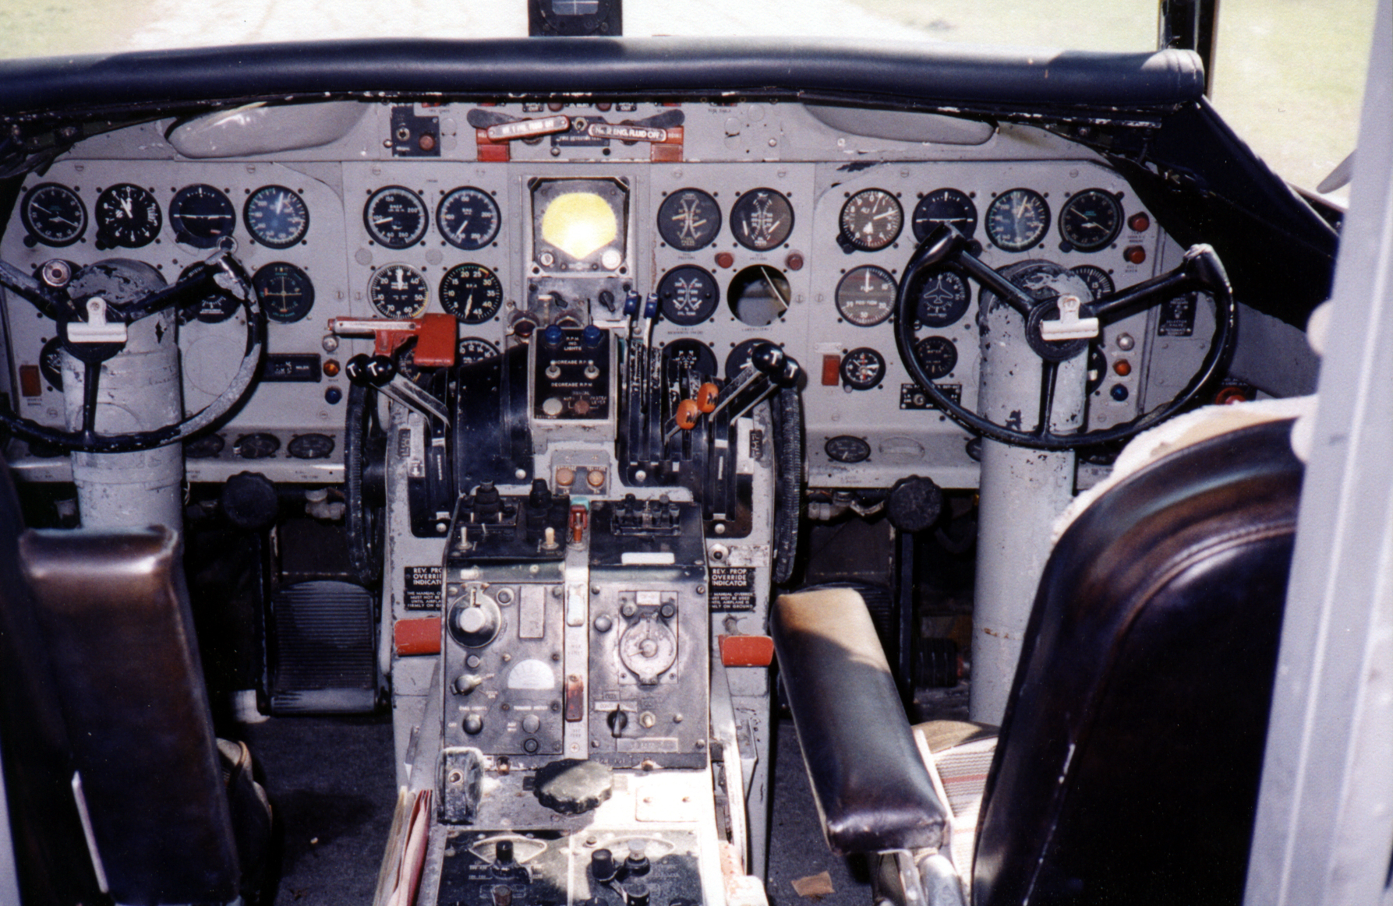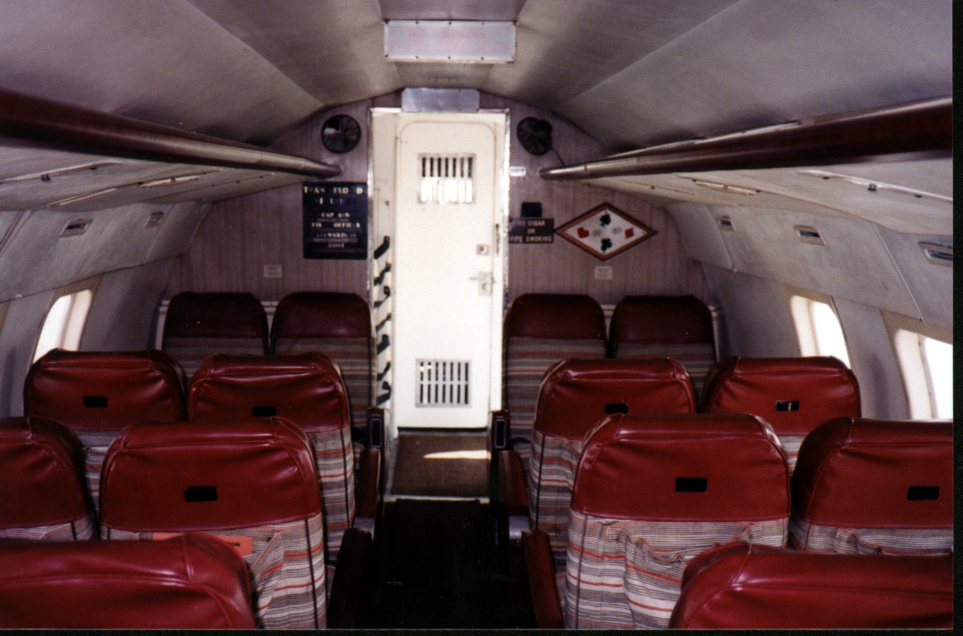

For those of you who have received a Prop-Liners Newsletter in the past, you'll notice our new look and feel. Printed entirely in color and adopting a much more newspaper-like quality, this and future editions of the newsletter will bring you a much more visually rewarding experience while keeping you just as updated on the current status of the aircraft.
These changes were brought about due to the addition of Del Laughery to our membership roll. Del grew up on Air Force bases then spent 21 years of his adult life as a nuclear power plant supervisor and electronics technician aboard five types of submarines in the U.S. Navy. Also while in the military he earned a BS in Workforce Education as well as his private pilot certificate. Now employed with The Hartford Financial Group of Hartford, CT as an education consultant, Del brings his considerable photographic and desktop publishing skills to our organization.
Del's task is to record and bring to you all of the aircraft updates including up to the moment photographs when appropriate as well as historical information regarding the Convair 240 and other propellor-driven airliners. This is no small job but based on his initial efforts on this quarter's newsletter, he is more than capable of filling this desperately needed position.
Welcome Del!

