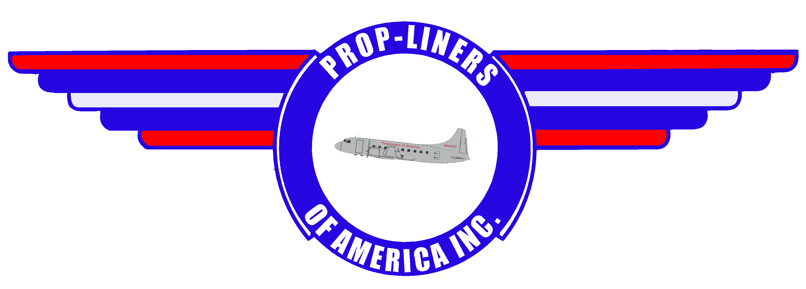

Volume 11 58 Lindbergh Dr Brainaird Airport Hartford, CT 06114 4th Quarter 2003

  Prop-Liners received a very nice donation from Ann Genewicz of her late husband’s flight equipment from the US Air Force and his career with Allegheny, Mohawk, and USAir. The donation includes all flight training manuals, air navigation training manuals, weather manuals, two photographs of a C-123 Provider somewhere in Vietnam, a USAF navigation chart for the Western U.S. and another for the Azores. Additionally, we received a new (still in the plastic bag) USAF flight suit and his flight helmet and oxygen mask. Finally, the donation included his flight manuals from the airlines including an Allegheny Convair 580 Pilot Operating Handbook (POH), an Allegheny Douglas DC-9-30 POH, and a USAir Boeing 737-300 POH. This is quite a donation and we are very thankful for Ann’s generosity!  November saw some Prop-Liners members converge on Brainard Field for some much needed preservation on the maintenance stairs we acquired last  spring from the New Jersey Aviation Hall of Fame. As you can see (Before & After picture on next page), mother nature had been taking her toll on the stairs. With Winter fast approaching it seemed appropriate to get the corrosion problem under control. So armed with metal brushes and paint, our volunteers performed some fine work to ensure these stairs are ready for use when the CV-240 needs them.  Overlooked in our last newsletter was the R-2800 generator donated by member Alan Booth, a retired AA mechanic, along with a lighted TWA travel agency sign now hanging in the museum. Thank you, Alan!  Albert Mitchell, a new member from Old Lyme, CT, donated three photos of a very rare aircraft called the “Rainbow.” Al flew the Convair 240 for American  (Continued on Pg.2 | Image Corner  This quarter’s images come from the personal collection of Mr. Eddie Coates who gave us his kind permission to use them in this newsletter.  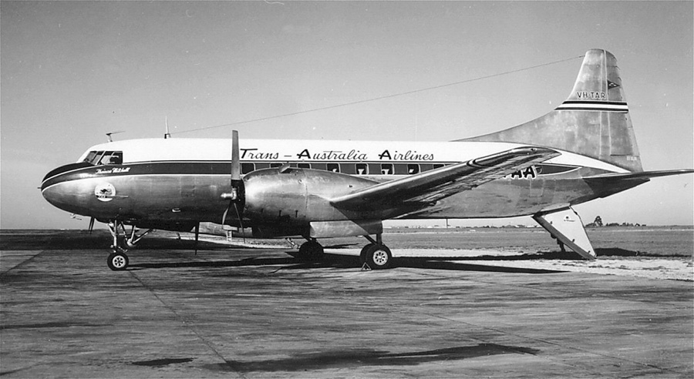  VH-TAR in Trans-Australia Airlines livery.  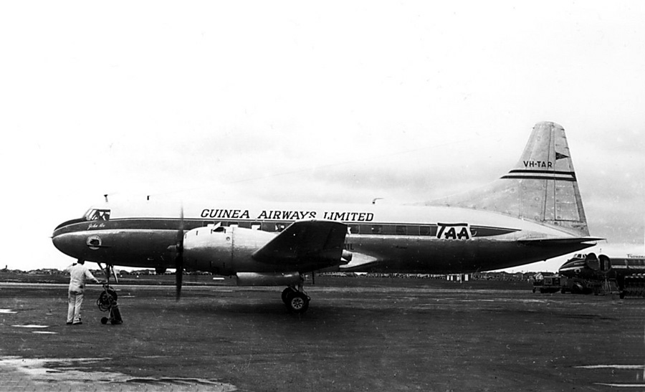  VH-TAR at Essendon Airport, Melbourne, Aug 1958 in Guinea Airways Limited livery.  History: Registered VH-TAR to the A.N.A.C. 3/24/48. Completed 9/21/48. Delivered to Trans-Australia Airlines 10/8/48, as VH-TAR ‘Thomas Mitchell’. Renamed ‘William Dempster’ & later ‘John Roe’. It was wet-leased from T.A.A., by Guinea Airways,  (Continued on Pg.2)

Prop-Liners of America, INC Page 2
Happenings (continued from page 1)  among other aircraft and also few for Pan Am and was a test pilot for Pratt & Whitney. He flew the B-45 Tornado as a test bed aircraft and the B-17 Flying Fortress with the T-34 turbo-prop engine mounted in the nose. We’ll feature the “Rainbow” in the next edition of the newsletter. Thank you for thinking of us, Albert.  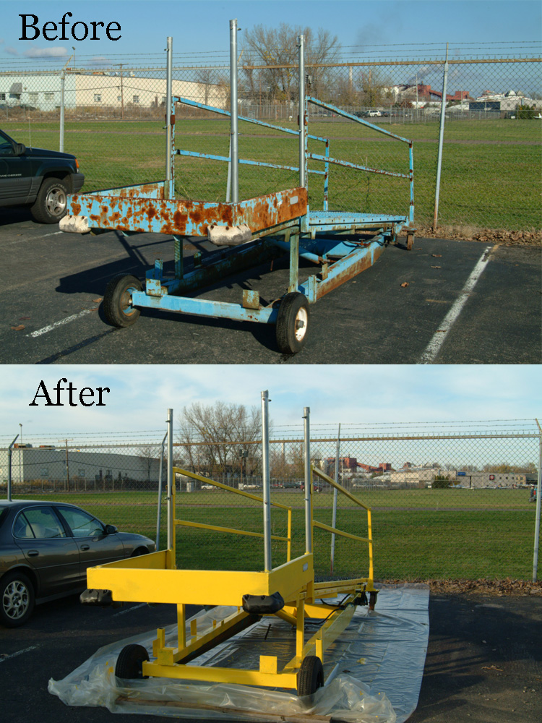  Prop-Liners maintenance stairs before and after the preservation effort at Brainard Field.  John Masterson, also retired from AA, has contributed several photographs to our museum along with various aircraft models and clothing. Thanks, John!  Bill Bradshaw, president of Prop-Liners, recently received a donation from Earl and Lillian Bradshaw in the form of a complete set of American Airlines china from 1973 and a very rare ashtray from an AA Boeing 747. Other items donated were a 1930’s vintage air routing map from AA and a PAA first class menu from their Bermuda flights along with several decks of playing cards from various airlines. Your kindness is very appreciated, Earl and Lillian! | Image Corner (continued from page 1)  7/21/58, operating in T.A.A. colors, with 'GUINEA AIRWAYS LIMITED' painted above cabin windows.  It was used to compete with Butler Air Transport on the Adelaide-Broken Hill route. Withdrawn from service by G.A.L. 7/31/59 & returned to T.A.A. 8/1/59. Withdrawn from service by T.A.A. Sold 12/7/59 to the Beldex Corp., U.S.A. & reregistered N9314R. It was purchased by Monsanto Chemical Co. 12/7/59 & reregistered N2007. To General Dynamics 1/65 & reregistered N240R. It was converted to CV-600 standard in 1965. Purchased by the Stromberg-Carlson Corp. 12/7/70 & reregistered N123SC. Purchased by Aviation Office of Alabama 1/30/75. Operated by the Aviation Office of America, Beaumont, Texas. To National Aero Associates, Inc. 1/30/75. Sold to Miami Aviation Corp. 4/12/76. Sold to Aérolineas Colonia, Uruguay, 4/12/76 & reregistered CX-BJL. Last known status: Stored at Laguna de Los Patos, Colonia, Uruguay, 11/86.  Military Veterans Receive Discounted Memberships  A new membership level has been created for military veterans. They pay only half price for any Prop-Liners membership and receive full benefits as well as a 25% discount on gift shop items.  Charter Sponsor Program  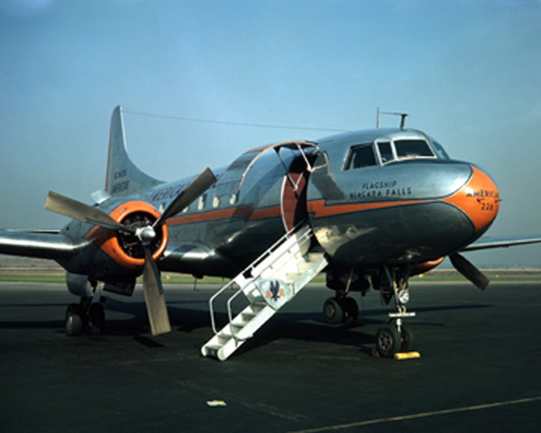  Are you looking for a way to support Prop-Liners without becoming an actual member? Charter Sponsorship allows you to assist us restore and exhibit propeller-driven airliners and military classics to honor the memory of all who served in them. Charter Sponsors receive a certificate suitable for framing, photographs of our aircraft, and their name listed on the Prop-Liners Honor Roll to be kept on permanent display at the museum at Brainard Airport.

Prop-Liners of America, INC Page 3
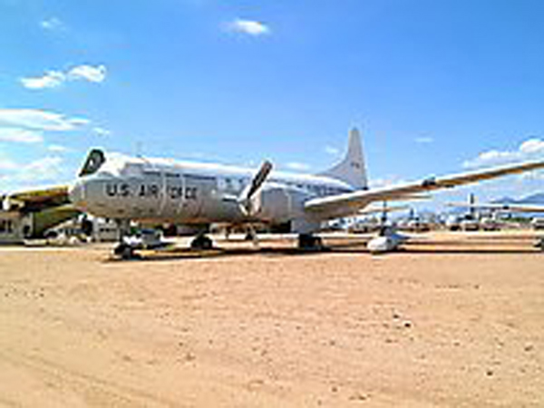  USAF Convair C-131  Prop-Liners Visits Davis-Monthan AFB  Not too long ago, Del Laughery, your humble editor, visited DM for a tour of the bone yard. Shirley Beene, a member of the Aircraft Maintenance and Regeneration Center (AMARC) staff provided a wonderful driving tour of the facility, and spoke of the process of acquiring an aircraft once the military decides to dispose of it. Naturally, Shirley was interested in our desires (one of which is pictured above) and indicated she would keep us in mind should one of these aircraft become available.  Contact Information  Web Site: www.prop-liners.com  Phone: 860 684-4988  email:  Bill Bradshaw - wbradshaw@prop-liners.com  Del Laughery – cavu@myeastern.com  About This Issue  Prop-Liners of America Newsletter is the official news source for our non-profit organization, and complements the website at www.prop-liners.com. All content is the property of Prop-Liners of America, INC and may be reproduced without permission.  If you have a Prop-Liner story or picture and would like to submit it for publication, please send it to the editor.  Editor: Del Laughery cavu@myeastern.com | Sponsors  Please support our very important sponsors!            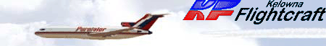          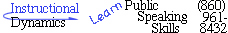  Next Meeting  The next Prop-Liners of America meeting will occur on January 24, 2004 at 11:00AM with a snow date of January 31, 2004 at the same time.  Next Issue  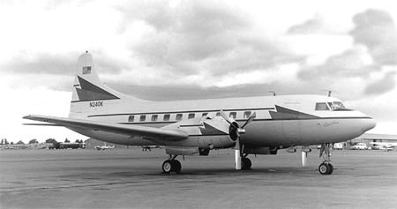  Join us for a look at Convair 240 N240K. Known as Caroline, this was the first private aircraft used during a presidential campaign.  Please visit our friends at these fine museums    
  Mailing Address:  Prop-Liners of America, INC  P.O. Box 198  Stafford Springs, CT 06076-0198 | Museum Address:  Prop-Liners of America, INC  58 Lindbergh Drive  Brainard Airport  Hartford, CT 06114-2123

Prop-Liners of America, INC Page 4
Other Prop-  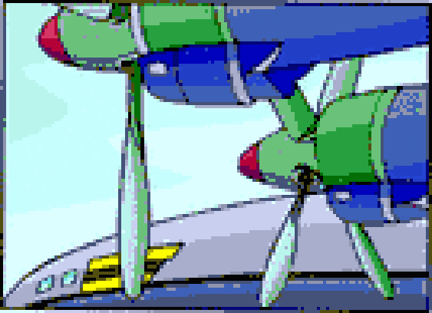  Liners  We are just learning of the news that the former Eastern DC-7B N836D, serial #45345, has been purchased by Carlos Gomez to be restored and flown on the air show circuit. It will carry the Eastern colors. This aircraft still has its original interior and wil be flown from its present location at Minneapolis-St. Paul (MSP) to Florida in the spring of 2004. Carlos owns and operates Turks Air Cargo and currently operates a DC-7BF, DC-6A, and a C-54G.  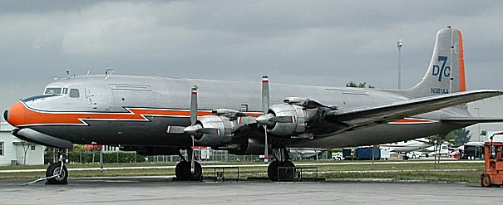  DC-7BF N381AA  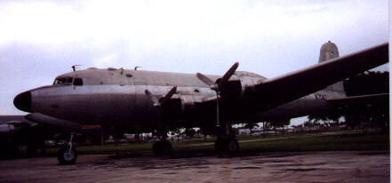  C-54G N708Z  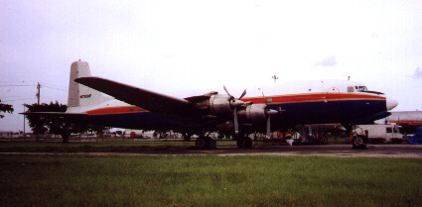  DC-6A N70BF | Feeling Like a Million – visitors, that is.  The Prop-Liners of America web site passed the one million visitor mark in late September 2003. The site is now averaging 50,000+ visitors per month, with the month of October 2003 bringing 59,901.  There are always new items to view on the Prop-Liners web site located at http://www.prop-liners.com. Be sure to check us out often!  Our Newest Sponsor    Prop-Liners is pleased to announce Arcadia Publishing has signed on as our newest sponsor. Publishers of regional and local interest books, you may visit them on the web at http://www.arcadiapublishing.com, or simply follow the link from the Prop-Liners site to theirs.  Donations  Prop-Liners of America is a non-profit 501(c)3 organization and receives no monetary support from local, state, or federal agencies. Our only means of support is from our members and the public who realize the value of maintaining our historic aircraft in flying condition and ultimately preventing their complete disappearance. We encourage you to look at Prop-Liners as you consider how to allocate your charitable funds.  There are many ways to support the historical preservation activities at Prop-Liners. One unique method is to consider donating your privately owned aircraft. Prop-Liners will issue you a certificate for the fair market value of the aircraft. This certificate is used on your taxes to claim the donation. In many cases, the value on the certificate is more than you would realize if you sold the aircraft outright, plus, there is certainly less wait time to complete the transaction.  Other items which may be donated are aircraft memorabilia, actual aircraft parts and engines, your valuable time and expertise, and, of course, your cash.  Please help us as we maintain this important link to America’s aviation past!

Promotional Items Order Form

Item Color Price Size Quantity Total

Adjustable Baseball Hat with Prop-Liners logo * ______* $8.00
Gray T-shirt w/ Prop-Liner logo over left breast $8.00 L XL
T-shirt w/Prop-Liners logo on back ** ______** $8.00 L XL
License Plate w/Prop-Liners logo $4.00
License Plate Frame w/Prop-Liners logo $3.00
Convair 240 Vinyl Decal $2.00
Convair 240 8X10 Color Photo $2.00
Shipping*** $5.95 or $1.95
* Available in Navy, Royal, Black, Lt. Green, Dark Green, & Burgundy
** Available in Navy, Royal, Black, Green, & Purple Total
***All items are shipped Priority Mail within the U.S. Please add $5.95 for
shipping and handling. Pictures & decals, if ordered separately, will be shipped
parcel post. Please add only $1.95 for shipping and handling.

Membership Information and Application
See our website at www.prop-liners.com to view details of each membership type.

Membership Types (circle your choice of membership):
Presidents Club: $1000 for lifetime membership
Captains Club: $500 for the first year, $400 for the second year, which elevates you to a lifetime membership.
Skyrider: $250/year
Ground Crew: $100/year
Observer: $40/year
Family $75/year
Name:

Street:
City: State: Zip Code:
Phone (including area code): ( ) email Address:

If your membership level entitles you to a T-Shirt, please circle the size desired: L XL

Make all promotional material and membership checks payable to Prop-Liners of America, INC.
and send it along with this form to:
Prop-Liners of America, INC.
PO Box 198
Stafford Springs, CT 06076-0198

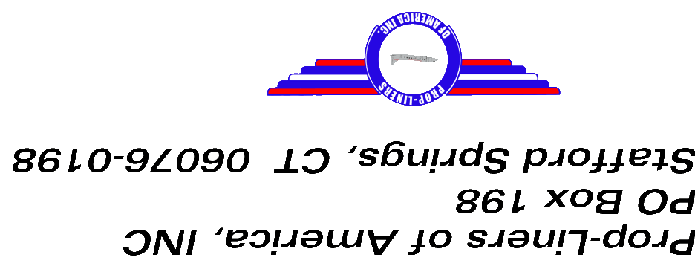

  "The World's Premier Airline Collectible Event!"  Airliners International is the annual convention of the World Airline Historical Society where enthusiasts from around the world gather to buy, sell and trade their airline memorabilia. We also feature side trips to local aviation sites of interest.  This is the world's largest gathering of people interested in airline collectibles. Over 1,000 people attended the 2001 show in Miami, Florida. If you're interested in photos, postcards, slides, timetables, models, playing cards, stickers, and more, this event is for you!  WORLD AIRLINE HISTORICAL SOCIETY, INC.  P.O. Box 660583  Miami Springs, FL 33266 USA  http://www.WAHOSOnline.com  Information@WAHSOnline.com  EDITORS: William M. Demarest & Philip Glatt  Fax: 1-786-331-7024 | 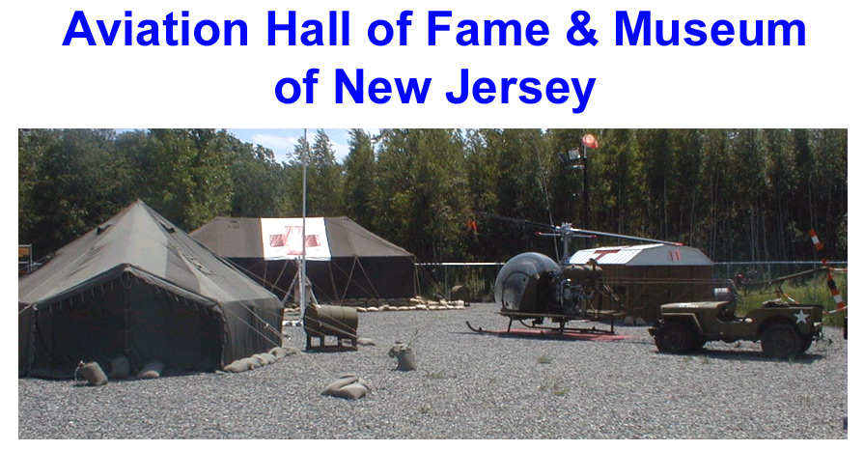  “Preserving 210 years of New Jersey Aviation Heritage.”  The museum is open to the public Tuesday through Sunday. Admission and observed holiday information is available on our web site.  Groups of 10 or more are encouraged to call ahead to ensure the availability of a tour guide.  Aviation Hall of Fame & Museum of New Jersey  400 Fred Wehran Drive  Teterboro Airport  Teterboro, NJ 07608 USA  http://www.njahof.org  info@njahof.org

